January 15, 2012, 2:34 PM Paul Krugman

The Great Gatsby Curve

Alan Krueger, the chairman of the Council of Economic Advisers — who is not only a colleague of mine at Princeton, but gets a lot of my mail and vice versa — gave a [very informative speech](http://www.americanprogress.org/events/2012/01/krueger.html) on inequality last week that should have received more press than it did. Much of it was stuff that inequality mavens already know, but he had one striking result that was what I suspected but hadn’t seen demonstrated: a clear negative relationship between inequality at a point in time and intergenerational social mobility.

Below is what he dubs the Great Gatsby Curve. On the horizontal axis is the Gini coefficient, a measure of inequality. On the vertical axis is the intergenerational elasticity of income — how much a 1 percent rise in your father’s income affects your expected income; the higher this number, the lower is social mobility.

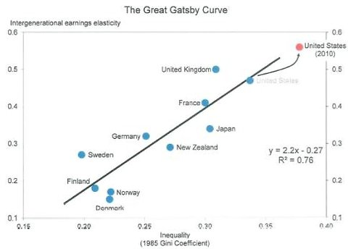

As he shows, America is both especially unequal and has especially low mobility. But he also argues that because we are even more unequal now than we were a generation ago, we should expect even less social mobility going forward.

Very illuminating — and disturbing.

More on this topic: <http://socialcapital.wordpress.com/category/paul-krugman/>